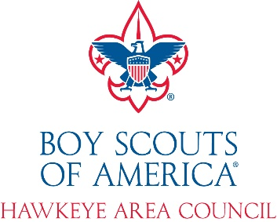
Unit # District

2025 Popcorn Sale Unit Challenge Incentive

Saturday, May 2, 2026

Imagine… a day at camp for your Scouts and their buddies filled with open program, staffed for you, and including food… for free!

This event is an exclusive day at camp for Units that successfully

complete the popcorn sales challenge.

Here’s How You Can Earn This Incentive Event! Goal Actual

- Increase your unit retail sales by 10% from 2024 2024 Sales $
(New units- contact Amanda Speidel for your goal)

X 10% $

2025 Goal $________

2025 Sales $

- Turn in 50% of your unit cost in sales by October 6, 2025 Turned in? Yes or No
(Report will be emailed by September 29, 2025)

- Do one fun challenge with your Scouts to keep them motivated. List here:

- Sell at least 10 Military Donations
Yes or No
Yes or No
- Zero Returns of Popcorn at the end of the sale

This form for Kernel Record Keeping only, please fill out Google Form located on the Popcorn Website https://forms.gle/c7nsE21BGkWKLFkLA by December 1, 2025

