# Happy Halloween

Join the Cub Scout Adventure!

Fun for boys and girls in grades K-5

**FOR MORE INFORMATION CONTACT:**

# Happy Halloween

Join the Cub Scout Adventure!

Fun for boys and girls in grades K-5

**FOR MORE INFORMATION CONTACT:**

# Happy Halloween

Join the Cub Scout Adventure!

Fun for boys and girls in grades K-5

**FOR MORE INFORMATION CONTACT:**

# Happy Halloween

Join the Cub Scout Adventure!

Fun for boys and girls in grades K-5

**FOR MORE INFORMATION CONTACT:**

# Happy Halloween

Join the Cub Scout Adventure!

Fun for boys and girls in grades K-5

**FOR MORE INFORMATION CONTACT:**

# Happy Halloween

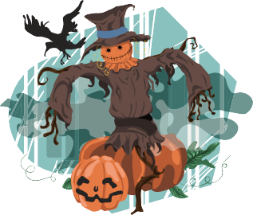Join the Cub Scout Adventure!

Fun for boys and girls in grades K-5

**FOR MORE INFORMATION CONTACT:**

# Happy Halloween

Join the Cub Scout Adventure!

Fun for boys and girls in grades K-5

**FOR MORE INFORMATION CONTACT:**

# Happy Halloween

Join the Cub Scout Adventure!

Fun for boys and girls in grades K-5

**FOR MORE INFORMATION CONTACT:**

# Happy Halloween

Join the Cub Scout Adventure!

Fun for boys and girls in grades K-5

**FOR MORE INFORMATION CONTACT:**

# Happy Halloween

Join the Cub Scout Adventure!

Fun for boys and girls in grades K-5

**FOR MORE INFORMATION CONTACT:**